**2.4 Producemobile: A Mini-Case Study**

We would like to share a brief spotlight on the Evanston Producemobile operation. This is an excellent example of how data mindfulness can lead to effective community responses to food insecurity. We would like to thank Rita Bailey, Shawn Iles for cooperating with us during our summer project.

**2.4.1 Organization Description**

Producemobile is a collaboration by the Interfaith Action Committee of Evanston and the Greater Chicago Food Depository. It operates two locations in Evanston. The food truck is provided by the GCFD, while the volunteers are provided by Interfaith Action Committee. The frequency of operation is on the second Tuesday of each month. On offer are fresh fruits & vegetables, a selection of meats, among other produce.

**2.4.2 Data Collection & Management Best Practices**

At each Producemobile operation, there is a rigorous and disciplined approach to Data Management. For instance, the following variables are conscientiously recorded at each distribution:

* **Site Name**: The location where distribution occurred
* **Date:** The date of the distribution
* **Inside/outside distribution:** Whether the distribution was indoors or outdoors
* **Amount of Produce Received:** How many lbs of produce were received from the GCFD?
* **Number of guests signed in:** How many guests were signed in?
* **Total Individuals Served:** How many individuals were served?
* **Truck Arrival time:** What time the truck from GCFD arrived?
* **Number of volunteers:** How many volunteers were present from the IAC?
* **Leftover Pickups:** Which organization picked up the leftovers?
* **Number of boxes for pickup:** How many excess boxes were picked up at the end of distribution?
* **Number of boxes of waste:** How many boxes are thrown into waste due to not being picked up?
* **Miscellaneous comments:** Anything that stood out at this distribution to take into account next time [free form text]

**2.4.3 The Operational Problem & Present Solution**

The key problem faced by Producemobile was a planning one: **“How to plan how much food to bring to a given distribution location to minimize excess and shortages?”** This requires prior knowledge about how many individuals will show up to a particular Producemobile food distribution. This is a classic problem faced by many retailers.

To address this problem, a Shawn Iles, a veteran volunteer in charge of the operation, essentially uses a combination of guesswork and intuition built over a long time working at the site location.  However, Shawn recognizes that there are numerous inefficiencies to this:

* For one, the operation is highly dependent on him and his intuition.
* Secondly, various trends that are beyond human detection are left unexplored.
  + This is especially problematic in the volatile COVID-19 era.

**2.4.4 A Potential Data-Driven Solution**

One of the big advantages of Producemobile is the wealth of data it collects about each distribution from 2016 to present. From a data management perspective, the following two characteristics followed by Producemobile are key:

* Consistently formatted and disciplined data collection at each distribution event
* Data storage in an easily accessible location (For Producemobile, this took the form of simple Excel sheets)

With marginal effort, this allows a data driven solution to a classic business problem: **forecasting via a time series analysis**. Through simple time-series methods, we can detect things the following in the data:

* Trend over time
* Seasonal effects
* Latent cyclic behavior

Using this knowledge, forecasting the number of attendees at a particular Producemobile distribution becomes possible. This allows Producemobile to better serve its community by ensuring that shortages and excesses are avoided.

However, the real power of disciplined data collection and management lies beyond solely forecasting demand at a particular location: a virtuous cycle occurs that simultaneously improves Producemobile’s forecasting models and thus enhances Producemobiles ability to better serve its constituents. As data is collected each time, model parameters can be updated based on the divergence of their forecast from the actual number of attendees that arrived at that distribution. Over time, the forecasting model becomes stronger and so does Producemobile’s ability to meet demand at its location. Such a scientifically sound approach also makes Producemobile’s case stronger when requesting food from GCFD or funding from other agencies. The approach can also be applied to other aspects of Producemobile’s operations such as requisitioning volunteers, etc.

**2.4.5 Forecasting in Action**

To illustrate the actionability of the above recommendation, our team at Everybody Eats built a time-series based forecasting model. The data we used consisted of 12 measurements (one per month) for each year from 2016 - August 2020. The model used was a Holt-Winters model. Seasonal decomposition and linear interpolation was used to impute null values.

We analyzed the following three key aspects of Producemobile’s operations:

* ***Number of individuals served at each distribution***
* ***Amount of food received from GCFD for each distribution***
* ***Number of volunteers expected to arrive at each distribution***

Here are some of our key insights:

* For number of individuals served at each distribution:
  + Tends to peak during: **March,  May, September, November**
  + Tends to fall during:  **January,  February, April, October, December**
* For the amount of food received from GCFD for each distribution:
  + Tends to peak during: **January, March, May, July, September, Novembe**r
  + Tends to fall during: **February, April, June, October, December**
* For the number of volunteers at each distribution:
  + Tends to peak during: **January, February, March, April, September, November**
  + Tends to fall during: **May, June, July, August, October, December**

The following are the **predictions for the above three metrics till the end of the year**:

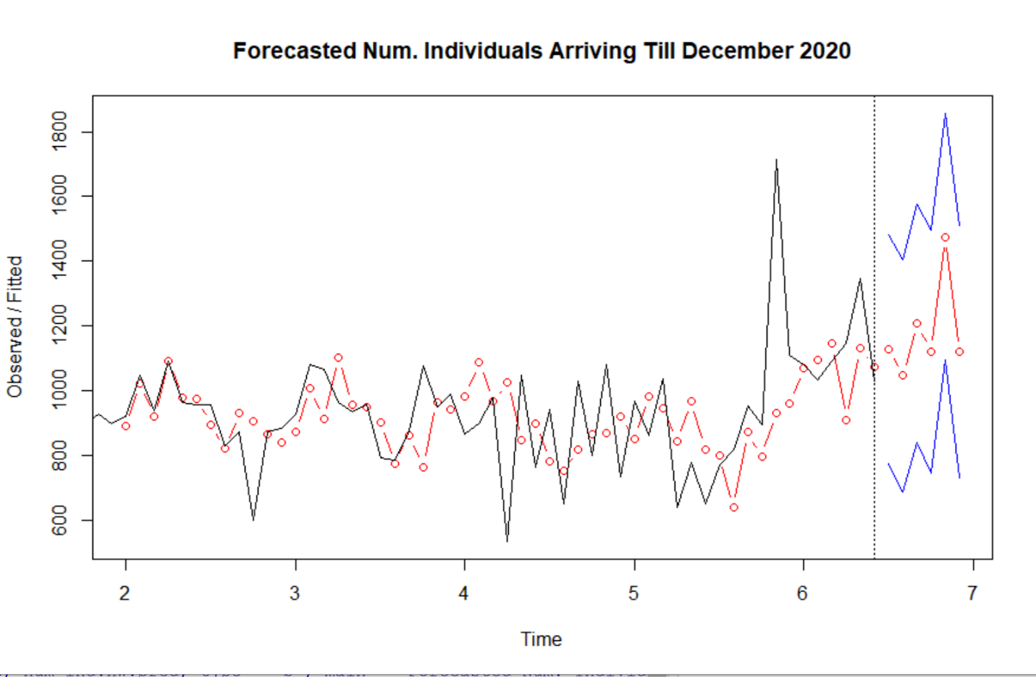

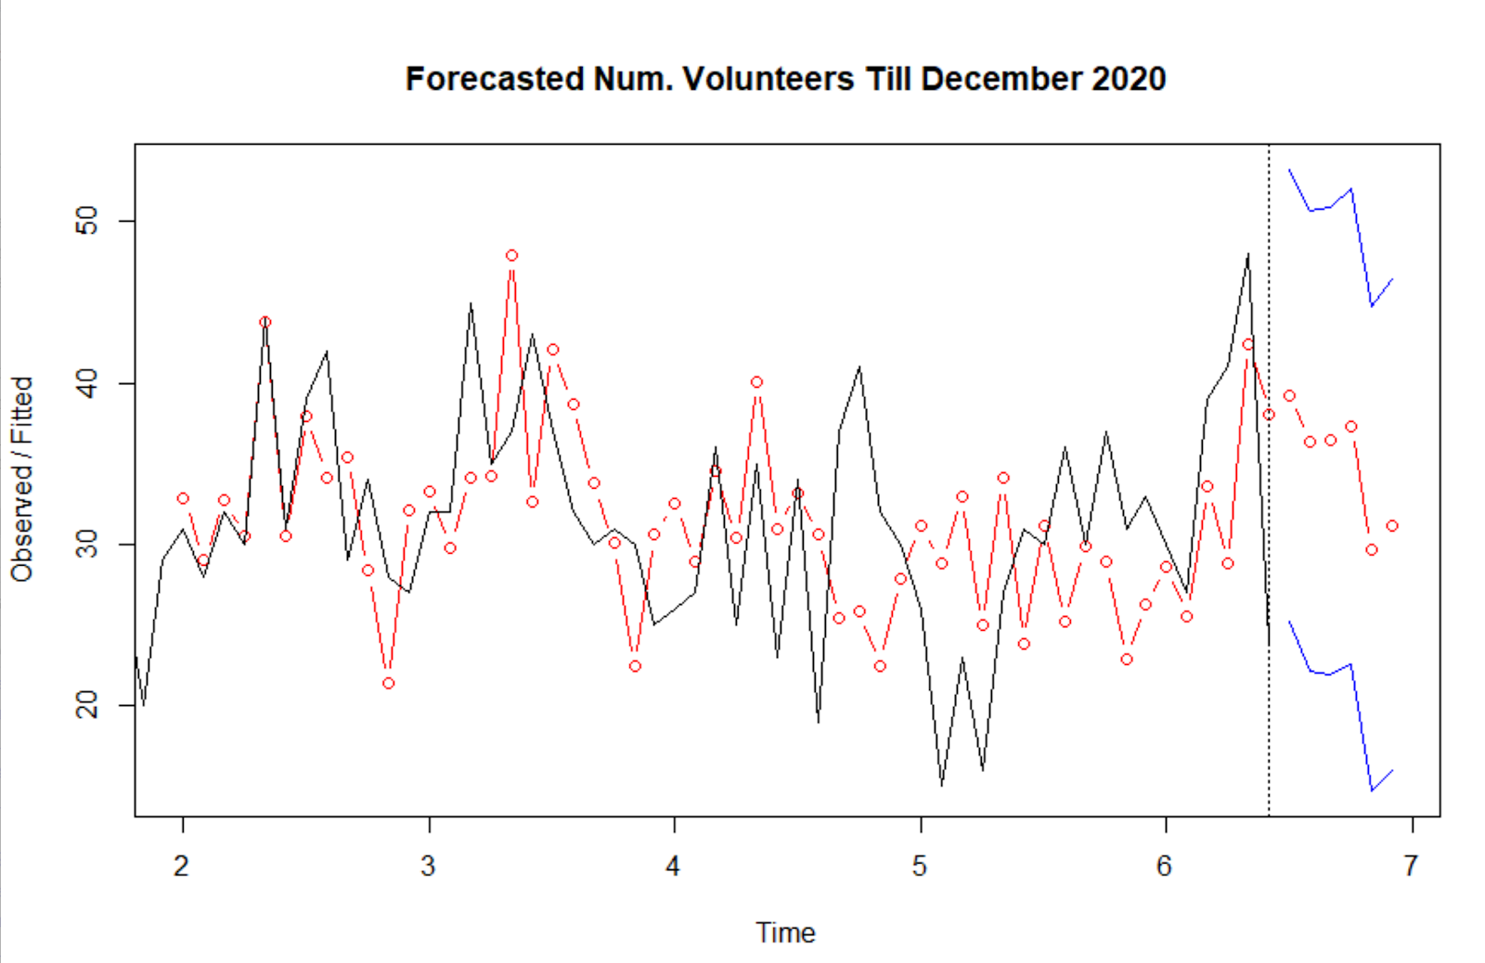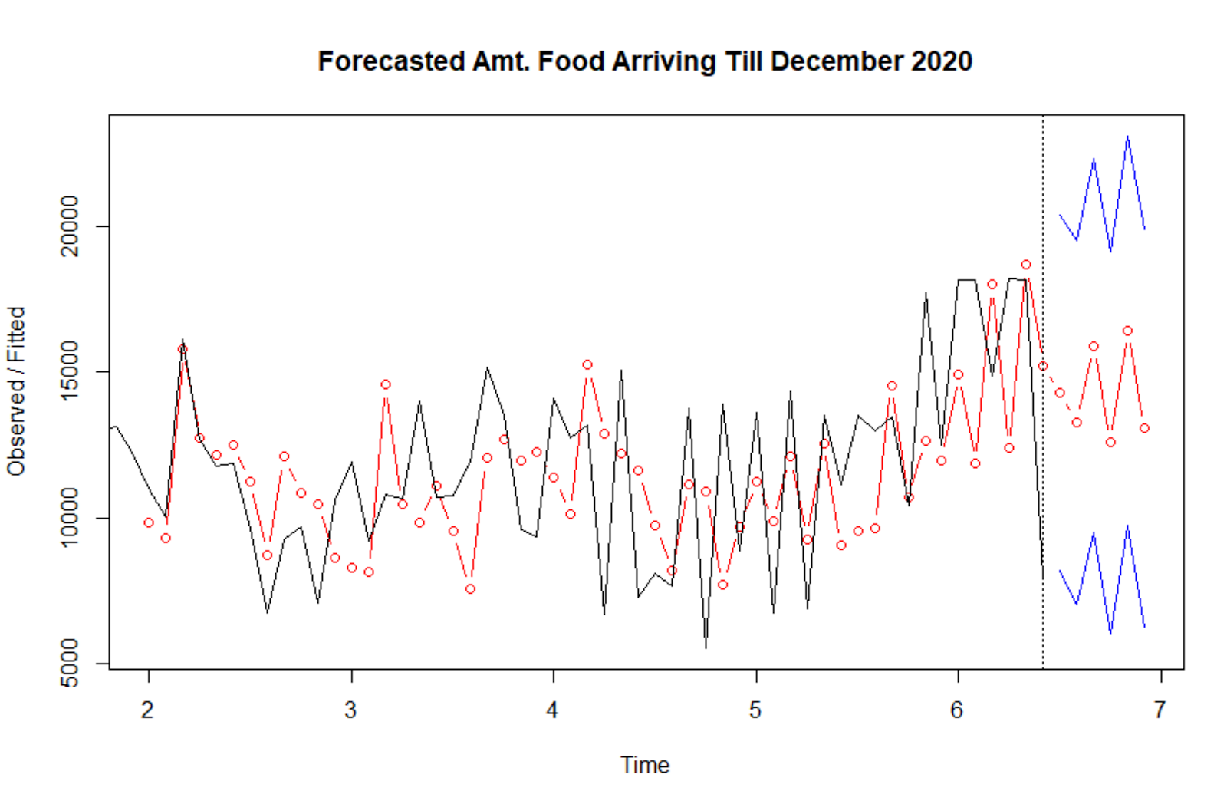

Some **Key Takeaways** from the above forecasts:

* The number of individuals is expected to rise till the end of 2020 (December)
* The amount of food received from GCFD is expected to stay level till the end of 2020
* The number of volunteers attending is expected to fall till the end of 2020.

**The key implication of the above is that there is a shortage of volunteers expected that coincides with an increase in the number of individuals attending Producemobile’s distributions, and a concurrent levelling of food arriving from GCFD.**

Finally, we can have a look at the decomposition of the three time series from 2016 to present (August 2020). This allows us to get a sense of the trend, and the seasonality of the time series.

1. **Number of Individuals Arriving at distributions from 2016-August 2020**

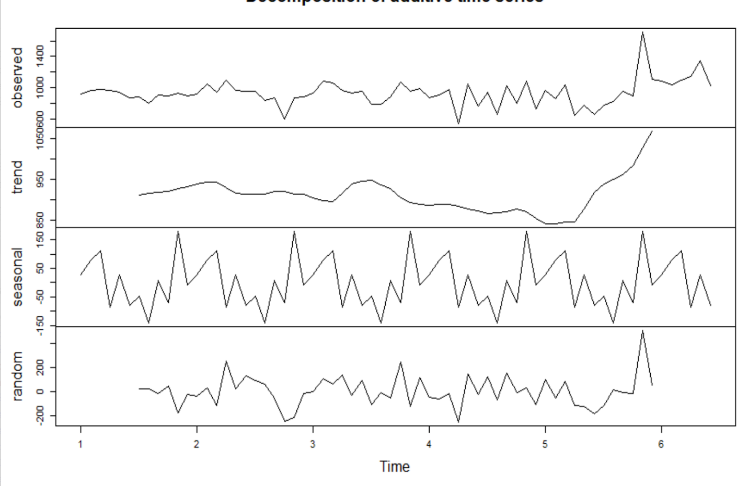

1. **Amount of food received from GCFD at each distribution from 2016 - August 2020**

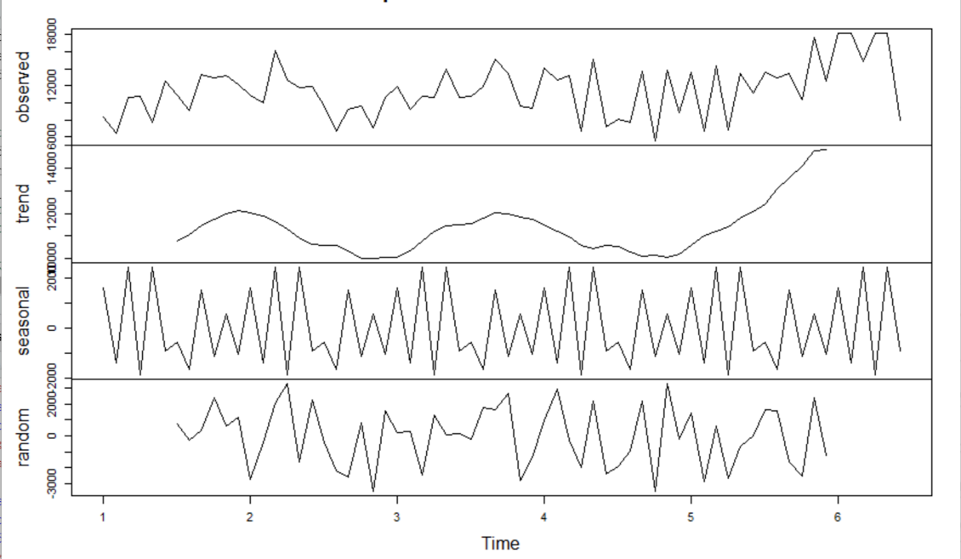

1. **Number of volunteers attending at each distribution from 2016 - August 2020**

